1. **Create a new React Application with the name “myfirstreact”, Run the application to print “welcome to the first session of React” as heading of that page.**

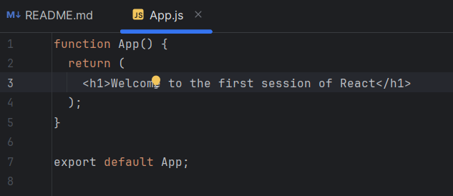

Terminal: npm start

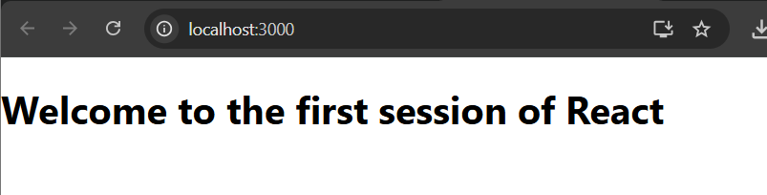

1. **Create a react app for Student Management Portal named StudentApp and create a component named Home which will display the Message “Welcome to the Home page of Student Management Portal”. Create another component named About and display the Message “Welcome to the About page of the Student Management Portal”. Create a third component named Contact and display the Message “Welcome to the Contact page of the Student Management Portal”. Call all the three components.**

**App.js**

import React from 'react';

import Home from './Components/Home';

import About from './Components/About';

import Contact from './Components/Contact';

function App() {

  return (

    <div>

      <Home />

      <About />

      <Contact />

    </div>

  );

}

export default App;

**Contact.js**

import React from 'react';

function Contact() {

  return (

    <h2>Welcome to the Contact page of the Student Management Portal</h2>

  );

}

export default Contact;

**About.js**

import React from 'react';

function About() {

  return (

    <h2>Welcome to the About page of the Student Management Portal</h2>

  );

}

export default About;

**Home.js**

import React from 'react';

function Home() {

  return (

    <h2>Welcome to the Home page of Student Management Portal</h2>

  );

}

export default Home;

**CMD: npm start**

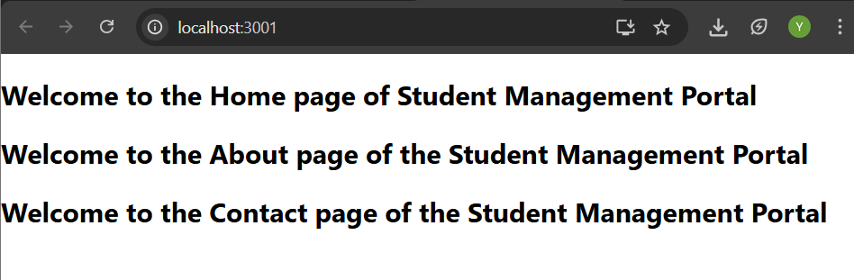

1. **Create a react app for Student Management Portal named scorecalculatorapp and create a function component named “CalculateScore” which will accept Name, School, Total and goal in order to calculate the average score of a student and display the same.**

**App.js**

import { CalculateScore } from './components/CalculateScore';

function App() {

  return (

    <div>

      <CalculateScore

        Name={"Yuvasri"}

        School={"Immaculate Higher Secondary School"}

        total={550}

        goal={6}

      />

    </div>

  );

}

export default App;

**CalculatorScore.js**

import '../Stylesheets/mystyle.css';

const percentToDecimal = (decimal) => {

  return (decimal.toFixed(2) + '%');

};

const calcScore = (total, goal) => {

  return percentToDecimal(total / goal);

};

export const CalculateScore = ({ Name, School, total, goal }) => (

  <div className="formatstyle">

    <h1><font color="Violet">Student Details:</font></h1>

    <div className="Name">

      <b><span> Name: </span></b>

      <span>{Name}</span>

    </div>

    <div className="School">

      <b><span> School: </span></b>

      <span>{School}</span>

    </div>

    <div className="Total">

      <b><span>Total: </span></b>

      <span>{total}</span>

      <span> Marks</span>

    </div>

    <div className="Score">

      <b>Score:</b>

      <span>{calcScore(total, goal)}</span>

    </div>

  </div>

);

**Mystyle.css**

.Name {

  font-weight: 300;

  color: rgb(178, 16, 86);

}

.School {

  color: rgb(190, 55, 174);

}

.Total {

  color: rgb(208, 68, 152);

}

.formatstyle {

  text-align: center;

  font-size: large;

}

.Score {

  color: rgb(119, 56, 140);

}

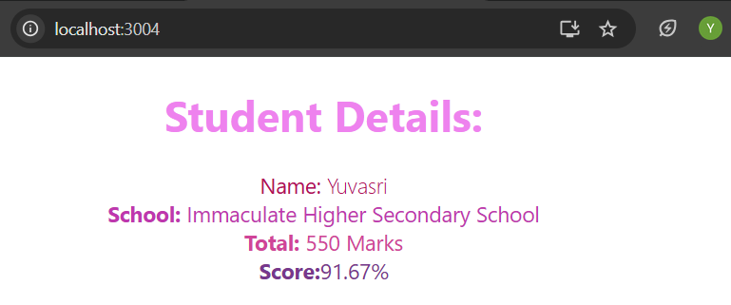

1. **Create a new react application using *create-react-app* tool with the name as “blogapp”**

**App.js**

import React from "react";

import Posts from "./Posts";

function App() {

  return (

    <div className="App" style={{ padding: "2rem", fontFamily: "Arial, sans-serif" }}>

      <Posts />

    </div>

  );

}

export default App;

**index.js**

import React from 'react';

import ReactDOM from 'react-dom/client';

import './index.css';

import App from './App';

const root = ReactDOM.createRoot(document.getElementById('root'));

root.render(

  <React.StrictMode>

    <App />

  </React.StrictMode>

);

**Post.js**

class Post {

  constructor(id, title, body) {

    this.id = id;

    this.title = title;

    this.body = body;

  }

}

export default Post;

**Posts.js**

import React from "react";

import Post from "./Post";

class Posts extends React.Component {

  constructor(props) {

    super(props);

    this.state = {

      posts: []

    };

  }

  componentDidMount() {

    this.loadPosts();

  }

  loadPosts = () => {

    const postList = [

      new Post(1, "Welcome to My Blog", "This blog shares interesting facts and tech tutorials."),

      new Post(2, "Bonjour à tous", "Ceci est un article de blog en français pour les débutants."),

      new Post(3, "React Tips", "Use functional components and hooks for cleaner code."),

      new Post(4, "Comment ça va ?", "J’espère que vous aimez apprendre React avec nous."),

      new Post(5, "Final Thoughts", "Consistency is key to becoming a good developer.")

    ];

    this.setState({ posts: postList });

  };

  render() {

    return (

      <div>

        <h1>📝 Blog Posts</h1>

        {this.state.posts.map((post) => (

          <div key={post.id} style={{border: "1px solid #ddd", padding: "1rem", margin: "1rem 0"}}>

            <h2>{post.title}</h2>

            <p>{post.body}</p>

          </div>

        ))}

      </div>

    );

  }

}

export default Posts;

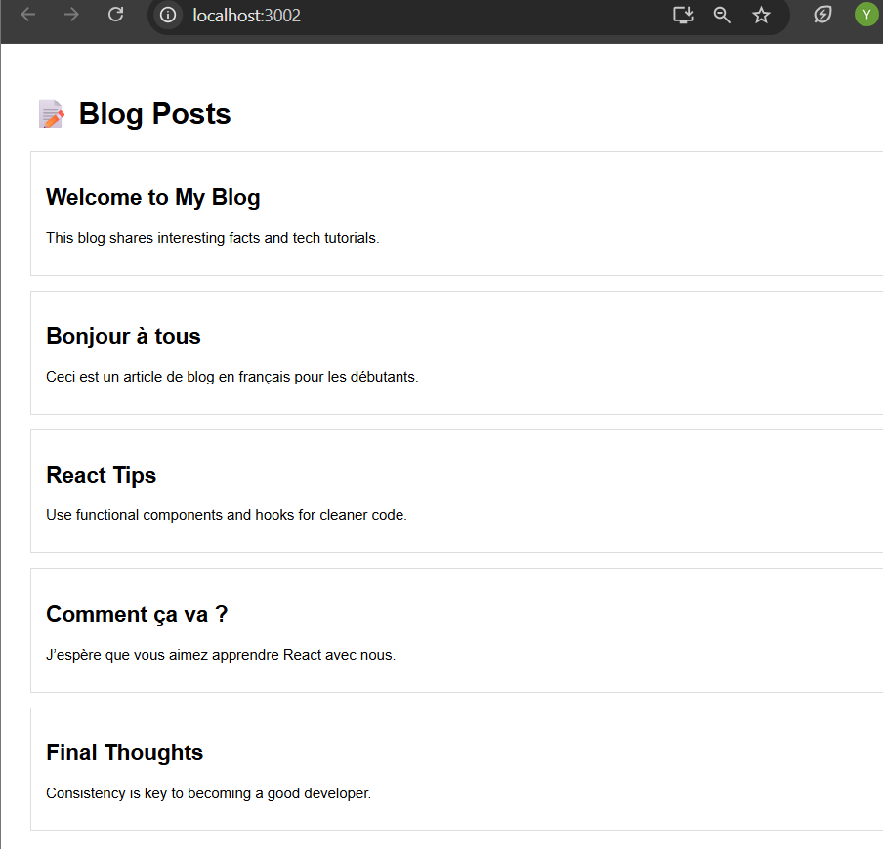

**5. Create a new CSS Module in a file called “CohortDetails.module.css”**

**App.js**

import React from 'react';

import CohortDetails from './components/CohortDetails';

function App() {

  const cohortData = [

    {

      name: 'INTADMDF10 - .NET FSD',

      startedOn: '22-Feb-2022',

      status: 'Scheduled',

      coach: 'Aathma',

      trainer: 'Jojo Jose'

    },

    {

      name: 'ADM21JF014 - Java FSD',

      startedOn: '10-Sep-2021',

      status: 'Ongoing',

      coach: 'Linda',

      trainer: 'Neeth'

    },

    {

      name: 'CDBJF21025 - Java FSD',

      startedOn: '24-Dec-2021',

      status: 'Ongoing',

      coach: 'Akash',

      trainer: 'Yash'

    }

  ];

  return (

    <div>

      <h2><b>Cohorts Details</b></h2>

      {cohortData.map((cohort, index) => (

        <CohortDetails key={index} cohort={cohort} />

      ))}

    </div>

  );

}

export default App;

**CohortsDetails.module.css**

.box {

  width: 300px;

  display: inline-block;

  margin: 10px;

  padding: 10px 20px;

  border: 1px solid black;

  border-radius: 10px;

}

dt {

  font-weight: 500;

}

**CohortsDetails.js**

import React from 'react';

import styles from './CohortDetails.module.css';

const CohortDetails = ({ cohort }) => {

  const { name, startedOn, status, coach, trainer } = cohort;

  const titleStyle = {

    color: status.toLowerCase() === 'ongoing' ? 'green' : 'blue'

  };

  return (

    <div className={styles.box}>

      <h3 style={titleStyle}>{name}</h3>

      <dl>

        <dt>Started On</dt>

        <dd>{startedOn}</dd>

        <dt>Current Status</dt>

        <dd>{status}</dd>

        <dt>Coach</dt>

        <dd>{coach}</dd>

        <dt>Trainer</dt>

        <dd>{trainer}</dd>

      </dl>

    </div>

  );

};

export default CohortDetails;

